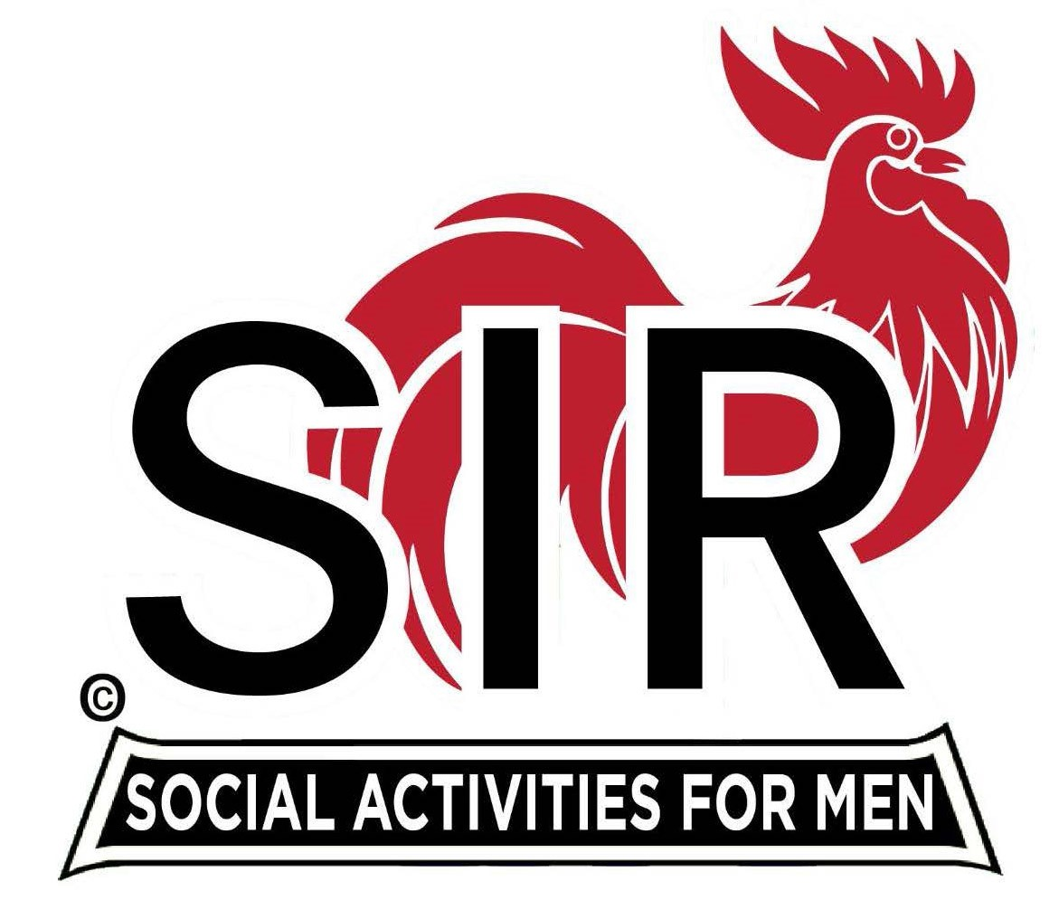
Las Trampas Branch 116
BEC Meeting Agenda
February 20, 2023, 9:15 AM at Boundary Oak

The Mission of SIR is to enhance the lives of our members through fun activities, events and luncheons while making friends for life.

9:15 am Call to order; Secretary, Paul Ramacciotti – Confirm quorum and
Approval of Jan 16, 2023 BEC meeting minutes

9:20 am Standing Reports

- Treasurer – Jeff Johnson, Ron Armijo – Audit & Financial Update
- Luncheon Report – Michael Schneider

- February Boundary Estimated Count

- Membership – Phil Goff

4. RAMP Department Head Reports:

- Recruitment – Don Schroeder
- Activity Coordinator – Mike Ward
- Member Relations - Michael Barrington
- Publicity – Paul Russell

5. Assessment – Fred Wachowicz

9:40 am Little SIR Updates – Alan Pope

- Speaker Info – Author, Isidra Mencos
- Birthday Boys – February

9:50 am Misc. Updates & New Business

- Volunteers Needed: Recruiting Assistants, Speaker Team Members, Member Relations Assistants, Activity Leader Assistants, Publicity Assistants

10:15 am Adjourn: Lunch Preparations

